Business Template

GLOBAL RETAIL SUPERSTORE SALES
Tamar Tutisani

Contents
GLOBAL RETAIL SUPERSTORE SALES 1
1 Business Description 3
1.1 Business background 3
1.2 Problems because of poor data management 3
1.3 Benefits from implementing a Data Warehouse 3
1.4 DATASETS DESCRIPTION 3
1.4.1 Dataset 1: Domestic Sales (SRC_DOMESTIC_SALES.csv) 4
1.4.2 Dataset 2: International Sales (SRC_INTERNATIONAL_SALES.csv) 4
1.4.3 Differences Between the Two Datasets 5
1.5 GRAIN / DIM / FACT 6
1.5.1 DIM_TIME_DAY: Date Dimension (Calendar Date Dimension, SCD Type 0) 7
1.5.2 DIM_PRODUCTS: Product Dimension (SCD Type 1) 8
1.5.3 DIM_CUSTOMERS: Customer Dimension (SCD Type 2) 9
1.5.4 DIM_GEOGRAPHY: Geography Dimension (SCD Type 1) 10
1.5.5 DIM_EMPLOYEES: Employee Dimension (SCD Type 1) 11
1.5.6 DIM_ORDER_ATTRIBUTES: Junk Dimension (SCD Type 0) 12
1.5.7 FCT_SALES_DD: Sales Fact Table (Transaction Grain, Daily Level) 13
1.5.8 STAR SCHEMA MODEL 14
1.5.9 SNOWFLAKE SCHEMA MODEL 16
2 Business Layer 3NF 19
2.1 Design Process 19
2.2 3NF Model 20
2.3 Table Definitions 20
3 Business Layer Dimensional Model 26
4 Logical Scheme 26
5 Data Flow 26
6 Fact Table Partitioning Strategy 26

Business Description

Business background
This project is built around a global retail superstore that sells a broad assortment of products across three major categories: Furniture, Office Supplies, and Technology. The business operates through two distinct sales channels, organized as two separate operational source systems: a Domestic Sales system covering orders placed in the United States and Canada, and an International Sales system covering orders placed across the remaining global markets (APAC, EU, EMEA, LATAM, and Africa).
Retail superstores of this kind compete on assortment breadth, price, and delivery speed across multiple customer segments (Consumer, Corporate, and Home Office) and across dozens of countries, states, and cities. Because orders, customers, products, and sales representatives are spread across two geographically and operationally distinct systems, the business has a genuine need to consolidate this data into a single source of truth in order to understand performance holistically rather than market-by-market.

Problems because of poor data management
Because domestic and international sales currently live in two separate operational systems with different attributes and identifier ranges, the business faces several recurring problems:
- No unified view of total sales, profit, or cost across all markets. Leadership has to manually reconcile two differently structured extracts to get a global picture.
- Inconsistent customer and product identifiers between the two systems make it difficult to track a customer’s full purchase history or a product’s full sales performance across both domestic and international markets.
- Sales rep performance (Employee dimension) is only tracked in the Domestic system, making it impossible today to evaluate territory coverage or staffing decisions on a global basis.
- Without a structured historical record, the business cannot reliably analyze trends over time, compare regions, or identify which product sub-categories are driving profit versus eroding it through excessive discounting.
- Ad-hoc spreadsheet-based reporting does not scale to the transaction volumes involved (over 1 million order lines across both systems) and is error-prone and slow to refresh.

Benefits from implementing a Data Warehouse
A Data Warehouse that consolidates both source systems into a single, well-modeled structure would let the business answer questions such as:
- Which product categories and sub-categories generate the highest sales and the highest profit, and where is profit being eroded by discounting?
- How do domestic and international markets compare in terms of sales, cost, and profit margin?
- Which regions, countries, or cities are the strongest and weakest performers, and how does this change over time?
- Which customer segments (Consumer, Corporate, Home Office) are most profitable, and do their purchasing patterns differ by market?
- How does sales rep / employee territory assignment correlate with regional sales performance?
- What is the impact of shipping mode and order priority on shipping cost and delivery performance?
Beyond answering these specific questions, a consolidated DWH would let the business run consistent, repeatable reporting across both source systems, support incremental daily or batch loading as new orders arrive, and provide a stable foundation for forecasting and further analytics as the business grows.

DATASETS DESCRIPTION
Two source datasets are used for this project, both derived from the same underlying retail superstore business but representing two distinct operational source systems, consistent with a real-world scenario where a company’s domestic and international divisions run on separate systems with overlapping but non-identical data structures.

Dataset 1: Domestic Sales (SRC_DOMESTIC_SALES.csv)
This dataset contains order-line-level sales transactions for the United States and Canada market. It represents the more mature, internally-operated system, and therefore carries richer operational detail, including full sales employee (rep) information, shipping mode, and order priority.
Domestic Sales — Identified Entities:
Entity / Dimension | Source Columns | Description
Date | Order Date, Ship Date | Calendar attributes of when an order was placed and shipped; supports trend analysis over time and the basis for the Date dimension and any time-based hierarchy (Year > Quarter > Month > Day).
Geography | Country, Region, City, Market | Where the order was placed; supports the geography hierarchy Market > Region > Country > City (State is not tracked in this source system).
Product | Product ID, Product Name, Category, Sub-Category | What was sold; supports the product hierarchy Category > Sub-Category > Product.
Customer | Customer ID, Customer Name, Segment | Who placed the order, and which customer segment (Consumer, Corporate, Home Office) they belong to.
Employee | Employee ID, Employee Name | The sales representative associated with the order’s region; tracked with full name in this system.
Order Operations | Ship Mode, Order Priority | Additional operational attributes describing how the order was fulfilled and its priority level.
Sales and Cost Measures (Domestic):
- Sales: total sale amount (revenue) for the order line, in USD.
- Cost: derived as Sales minus Profit; represents the cost basis of the goods sold for that order line.
- Profit: the margin earned on the order line (Sales minus Cost).
- Shipping Cost: the cost incurred to ship the order line.
- Quantity and Discount: supporting measures used to contextualize the sales and cost figures.

Dataset 2: International Sales (SRC_INTERNATIONAL_SALES.csv)
This dataset contains order-line-level sales transactions for all markets outside the United States and Canada: APAC, EU, EMEA, LATAM, and Africa. It represents a separate, more geography-detailed system used for international operations, it tracks State in addition to Country and City, but does not track Ship Mode, Order Priority, or sales employee names (only the employee’s natural identifier is carried over, without the descriptive name attribute).

International Sales — Identified Entities:
Entity / Dimension | Source Columns | Description
Date | Order Date, Ship Date | Calendar attributes of when an order was placed and shipped; same structure as the Domestic system, enabling a single conformed Date dimension.
Geography | Country, State, Region, City, Market | Where the order was placed; supports a deeper geography hierarchy Market > Region > Country > State > City (State is the additional attribute not present in the Domestic system).
Product | Product ID, Product Name, Category, Sub-Category | What was sold; identical structure to the Domestic system’s Product entity, and intentionally the dimension shared unmodified between both source systems.
Customer | Customer ID, Customer Name, Segment | Who placed the order; uses a distinct ID range/prefix from the Domestic system so the same natural customer can never collide across sources.
Employee | Employee ID (no name) | The sales representative’s natural identifier only; full name is not carried in this system, illustrating a deliberate attribute difference from the Domestic system.
Sales and Cost Measures (International):
- Sales: total sale amount (revenue) for the order line, in USD.
- Cost: derived as Sales minus Profit; represents the cost basis of the goods sold for that order line.
- Profit: the margin earned on the order line.
- Shipping Cost: the cost incurred to ship the order line.
- Quantity and Discount: supporting measures, identical in meaning to the Domestic system.

Differences Between the Two Datasets
The two datasets represent the same underlying retail business but are deliberately structured as two non-identical operational source systems, in line with the requirement that the two sources differ in attributes while sharing at least one common dimension:
Attribute | Domestic Sales System | International Sales System
Geography depth | Country, Region, City, Market only (no State) | Country, State, Region, City, Market (adds State)
Employee detail | Employee ID and Employee Name (full detail) | Employee ID only (natural key, no name)
Order operations | Includes Ship Mode and Order Priority | Does not include Ship Mode or Order Priority
Customer / Order / Row IDs | Prefixed distinctly (e.g. DOM-) so IDs never collide with the other system | Prefixed distinctly (e.g. INT-) so IDs never collide with the other system
Shared dimension | Product ID, Product Name, Category, and Sub-Category are identical and unmodified across both systems | Same — Product is the conformed dimension present in both sources, as required
Market coverage | United States, Canada | APAC, EU, EMEA, LATAM, Africa
Together, the two datasets contain over 1,000,000 order-line records covering a two-year period (2024–2025), satisfying the volume and recency requirement for the project, and both datasets share the Product dimension as the common entity that will allow the two sources to be conformed and combined within the Data Warehouse.

GRAIN / DIM / FACT
Step 1: Select the Business Process
The business process selected is retail sales order processing, the act of a customer placing and completing an order for one or more products in the superstore. This process is performed repeatedly across all markets, is supported by two operational source systems (Domestic and International), generates key performance metrics (sales revenue, cost, profit), and results in a measurable output (a completed, shipped order line). It is best expressed as the action verb ‘sell’: the superstore sells products to customers through a sales rep and ships them to a geography.
Step 2: Declare the Grain
The grain is: one row per individual product line item on a customer order.
In business terms: each row in the fact table represents a single product being sold on a specific order, on a specific date, to a specific customer, in a specific geography, fulfilled by a specific employee. If one order contains three different products, it produces three fact table rows, each with its own quantities and amounts.
This is a transaction grain fact table (the most common type, per the courseware). The grain was chosen at the order-line level rather than the order level because sales, cost, profit, and quantity are all recorded per product per order in the source data. Aggregating to the order level would lose the product-level detail that makes the data analytically valuable. The grain is not a periodic snapshot (we are not capturing stock levels at intervals) and not an accumulating snapshot (the process completes in a single measurable event).
Step 3: Identify the Dimensions
The dimensions answer ‘who, what, where, when, and how’ about each sales event:
- WHEN: Date dimension (DIM_TIME_DAY): covers Order Date; supports year/quarter/month/day drill-down.
- WHAT: Product dimension (DIM_PRODUCTS): what product was sold; carries the Category > Sub-Category > Product hierarchy.
- WHO (buyer): Customer dimension (DIM_CUSTOMERS): who bought it; includes segment.
- WHERE: Geography dimension (DIM_GEOGRAPHY): where the order was placed; carries Market > Region > Country > State/City hierarchy.
- WHO (seller): Employee dimension (DIM_EMPLOYEES): which sales rep handled the order’s territory.
- HOW: Junk dimension (DIM_ORDER_ATTRIBUTES): Ship Mode and Order Priority are low-cardinality flags that do not belong in the fact table and are not large enough to justify individual dimension tables.
- Degenerate dimension: Order ID lives in the fact table directly as a degenerate dimension (DD). It identifies the parent order that a line item belongs to, but the order itself has no other descriptive attributes beyond what the dimensions already cover, so no separate Order dimension table is needed.

Step 4: Identify the Facts
The facts answer ‘what did the process measure?’ at the order-line grain:
- SALES_AMT — total revenue for the order line (Sales). Fully additive across all dimensions.
- COST_AMT — cost of goods sold for the order line (derived as Sales − Profit). Fully additive.
- PROFIT_AMT — margin earned (Sales − Cost). Fully additive.
- SHIPPING_COST_AMT — cost to ship the order line. Additive.
- QUANTITY_CNT — number of units sold. Additive.
- DISCOUNT_AMT — discount applied to the order line (non-additive when viewed as a percentage, but stored as a proportion so it can be contextualized alongside the sales amount).

DIM_TIME_DAY: Date Dimension (Calendar Date Dimension, SCD Type 0)
Grain: one row per calendar day. Type 0 (dates never change). Populated independently of the source systems by the ETL system for the full 2024-2025 window.
Columns:
Column Name | Description | Data Type
DATE_ID | Surrogate primary key; integer in YYYYMMDD format (e.g. 20240115). Used as FK in fact table. | INTEGER NOT NULL
DATE_DT | The actual calendar date. | DATE NOT NULL
DAY_OF_WEEK_NO | Day number within the week (1 = Monday … 7 = Sunday). | INTEGER NOT NULL
DAY_OF_WEEK_DESC | Full name of the day (Monday, Tuesday … Sunday). | VARCHAR(25) NOT NULL
WEEKEND_FLAG | 1 if the day is a weekend day (Saturday or Sunday), 0 otherwise. | INTEGER NOT NULL
ISO_WEEK_NO | ISO week number within the year (1–52). | INTEGER NOT NULL
DAY_OF_MONTH_NO | Day number within the month (1–31). | INTEGER NOT NULL
MONTH_VALUE | Two-digit month string (01–12). | VARCHAR(2) NOT NULL
MONTH_DESC | Full month name (January … December). | VARCHAR(25) NOT NULL
QUARTER_VALUE | Quarter number (1–4). | VARCHAR(1) NOT NULL
QUARTER_DESC | Quarter label (Q1, Q2, Q3, Q4). | VARCHAR(2) NOT NULL
YEAR_VALUE | Four-digit year string (e.g. 2024). | VARCHAR(4) NOT NULL
INSERT_DT | Technical: date this row was inserted into the DWH. | DATE NOT NULL
UPDATE_DT | Technical: date this row was last updated. | DATE NOT NULL

Example data:
DATE_ID | DATE_DT | DAY_OF_WEEK_NO | DAY_OF_WEEK_DESC | WEEKEND_FLAG | ISO_WEEK_NO
20240106 | 2024-01-06 | 6 | Saturday | 1 | 1
20240108 | 2024-01-08 | 1 | Monday | 0 | 2
20241215 | 2024-12-15 | 7 | Sunday | 1 | 50

DAY_OF_MONTH_NO | MONTH_VALUE | MONTH_DESC | QUARTER_VALUE | QUARTER_DESC | YEAR_VALUE | INSERT_DT | UPDATE_DT
6 | 01 | January | 1 | Q1 | 2024 | 2024-01-01 | 2024-01-01
8 | 01 | January | 1 | Q1 | 2024 | 2024-01-01 | 2024-01-01
15 | 12 | December | 4 | Q4 | 2024 | 2024-01-01 | 2024-01-01

DIM_PRODUCTS: Product Dimension (SCD Type 1)
Grain: one row per unique product. Hierarchy embedded: Category > Sub-Category > Product. Conformed dimension, populated from both source systems.
Columns:
Column Name | Description | Data Type
PRODUCT_SURR_ID | Surrogate primary key; generated by sequence. Used as FK in fact table. | BIGINT NOT NULL
PRODUCT_SRC_ID | Natural key from source system (Product ID field, e.g. OFF-PA-10002005). | VARCHAR(50) NOT NULL
PRODUCT_NAME | Full product name as recorded in the source system. | VARCHAR(255) NOT NULL
PRODUCT_CATEGORY_ID | Surrogate ID for the product’s category (from CE_PRODUCT_CATEGORIES in 3NF). | BIGINT NOT NULL
PRODUCT_CATEGORY_NAME | Category name (Furniture, Office Supplies, Technology). | VARCHAR(100) NOT NULL
PRODUCT_SUBCATEGORY_ID | Surrogate ID for the product’s sub-category (from CE_PRODUCT_SUBCATEGORIES in 3NF). | BIGINT NOT NULL
PRODUCT_SUBCATEGORY_NAME | Sub-category name (e.g. Chairs, Paper, Phones). | VARCHAR(100) NOT NULL
INSERT_DT | Technical: date this row was inserted into the DWH. | DATE NOT NULL
UPDATE_DT | Technical: date this row was last updated (SCD1 overwrite). | DATE NOT NULL
SOURCE_SYSTEM | Source system that provided this record (e.g. SA_DOMESTIC or SA_INTERNATIONAL). | VARCHAR(100) NOT NULL
SOURCE_ENTITY | Source table that provided this record (e.g. SRC_DOMESTIC_SALES). | VARCHAR(100) NOT NULL

Example data:
PRODUCT_SURR_ID | PRODUCT_SRC_ID | PRODUCT_NAME | PRODUCT_CATEGORY_ID | PRODUCT_CATEGORY_NAME | PRODUCT_SUBCATEGORY_ID
1 | OFF-PA-10002005 | Xerox 2252 | 7 | Office Supplies | 2
2 | OFF-AR-10000833 | Binney & Smith Pencil Sharpener | 2 | Office Supplies | 1
3 | TEC-PH-10001970 | Samsung Galaxy S6 | 3 | Technology | 15

PRODUCT_SUBCATEGORY_NAME | INSERT_DT | UPDATE_DT | SOURCE_SYSTEM | SOURCE_ENTITY
Paper | 2024-01-01 | 2024-01-01 | SA_DOMESTIC | SRC_DOMESTIC_SALES
Art | 2024-01-01 | 2024-01-01 | SA_INTERNATIONAL | SRC_INTERNATIONAL_SALES
Phones | 2024-01-01 | 2024-01-01 | SA_DOMESTIC | SRC_DOMESTIC_SALES

DIM_CUSTOMERS: Customer Dimension (SCD Type 2)
Grain: one row per customer version. SCD Type 2 tracks historical changes to customer segment. Conformed across both source systems after ID de-prefixing.
Columns:
Column Name | Description | Data Type
CUSTOMER_SURR_ID | Surrogate primary key; generated by sequence. | BIGINT NOT NULL
CUSTOMER_SRC_ID | Natural key from source (Customer ID field, e.g. LS-172304 before prefixing). | VARCHAR(50) NOT NULL
CUSTOMER_NAME | Full name of the customer. | VARCHAR(255) NOT NULL
CUSTOMER_SEGMENT | Market segment: Consumer, Corporate, or Home Office. | VARCHAR(50) NOT NULL
START_DT | SCD2: effective start date of this version. Default 01/01/1990. | DATE NOT NULL
END_DT | SCD2: effective end date of this version. Default 31/12/9999. | DATE NOT NULL
IS_ACTIVE | SCD2: Y if this is the current active version, N if historical. | VARCHAR(1) NOT NULL
INSERT_DT | Technical: date this row was inserted into the DWH. | DATE NOT NULL
SOURCE_SYSTEM | Source system that provided this record. | VARCHAR(100) NOT NULL
SOURCE_ENTITY | Source table that provided this record. | VARCHAR(100) NOT NULL

Example data:
CUSTOMER_SURR_ID | CUSTOMER_SRC_ID | CUSTOMER_NAME | CUSTOMER_SEGMENT | START_DT
1 | DOM-LS-172304 | Lycoris Saunders | Consumer | 1990-01-01
2 | INT-MG-178902 | Michael Granlund | Home Office | 1990-01-01

END_DT | IS_ACTIVE | INSERT_DT | SOURCE_SYSTEM | SOURCE_ENTITY
9999-12-31 | Y | 2024-01-06 | SA_DOMESTIC | SRC_DOMESTIC_SALES
9999-12-31 | Y | 2024-01-01 | SA_INTERNATIONAL | SRC_INTERNATIONAL_SALES

DIM_GEOGRAPHY: Geography Dimension (SCD Type 1)
Grain: one row per unique city-level geography. Hierarchy embedded: Market > Region > Country > State > City. State is populated for International rows; set to N/A for Domestic rows where it is not tracked.
Columns:
Column Name | Description | Data Type
GEOGRAPHY_SURR_ID | Surrogate primary key; generated by sequence. | BIGINT NOT NULL
GEOGRAPHY_SRC_ID | Natural key: concatenated City + Country + Region (no single source key exists). | VARCHAR(255) NOT NULL
CITY_NAME | City name where the order was placed. | VARCHAR(100) NOT NULL
STATE_NAME | State or province. Populated for International records; ‘N/A’ for Domestic. | VARCHAR(100) NOT NULL
COUNTRY_NAME | Country name (e.g. United States, France, Japan). | VARCHAR(100) NOT NULL
REGION_NAME | Region within market (e.g. West, Central, North Asia). | VARCHAR(100) NOT NULL
MARKET_NAME | Top-level market grouping (US, Canada, APAC, EU, EMEA, LATAM, Africa). | VARCHAR(50) NOT NULL
INSERT_DT | Technical: date this row was inserted into the DWH. | DATE NOT NULL
UPDATE_DT | Technical: date this row was last updated. | DATE NOT NULL
SOURCE_SYSTEM | Source system that provided this record. | VARCHAR(100) NOT NULL
SOURCE_ENTITY | Source table that provided this record. | VARCHAR(100) NOT NULL

Example data:
GEOGRAPHY_SURR_ID | GEOGRAPHY_SRC_ID | CITY_NAME | STATE_NAME | COUNTRY_NAME
1 | Los Angeles_United States_West | Los Angeles | N/A | United States
2 | Echirolles_France_Central | Echirolles | Rhône-Alpes | France
3 | Toronto_Canada_North | Toronto | N/A | Canada

REGION_NAME | MARKET_NAME | INSERT_DT | UPDATE_DT | SOURCE_SYSTEM
West | US | 2024-01-01 | 2024-01-01 | SA_DOMESTIC
Central | EU | 2024-01-01 | 2024-01-01 | SA_INTERNATIONAL
North | Canada | 2024-01-01 | 2024-01-01 | SA_DOMESTIC

DIM_EMPLOYEES: Employee Dimension (SCD Type 1)
Grain: one row per sales representative. Full name is available from the Domestic system only; the International system contributes the Employee ID which is conformed during ETL.
Columns:
Column Name | Description | Data Type
EMPLOYEE_SURR_ID | Surrogate primary key; generated by sequence. | BIGINT NOT NULL
EMPLOYEE_SRC_ID | Natural key from source system (Employee ID field, e.g. EMP-1001). | VARCHAR(50) NOT NULL
EMPLOYEE_NAME | Full name of the sales representative. Sourced from Domestic system; set to ‘N/A’ if only available from International. | VARCHAR(255) NOT NULL
INSERT_DT | Technical: date this row was inserted into the DWH. | DATE NOT NULL
UPDATE_DT | Technical: date this row was last updated. | DATE NOT NULL
SOURCE_SYSTEM | Source system that provided this record. | VARCHAR(100) NOT NULL
SOURCE_ENTITY | Source table that provided this record. | VARCHAR(100) NOT NULL

Example data:
EMPLOYEE_SURR_ID | EMPLOYEE_SRC_ID | EMPLOYEE_NAME | INSERT_DT | UPDATE_DT | SOURCE_SYSTEM
1 | EMP-1001 | Zara Santos | 2024-01-01 | 2024-01-01 | SA_DOMESTIC
2 | EMP-1010 | N/A | 2024-01-01 | 2024-01-01 | SA_INTERNATIONAL
-1 | N/A | N/A | 2024-01-01 | 2024-01-01 | MANUAL

SOURCE_ENTITY
SRC_DOMESTIC_SALES
SRC_INTERNATIONAL_SALES
MANUAL

DIM_ORDER_ATTRIBUTES: Junk Dimension (SCD Type 0)
Grain: one row per unique combination of Ship Mode and Order Priority. This junk dimension consolidates two low-cardinality flags that describe the order event but do not belong to any of the primary business entities. Only available from the Domestic source system; International records reference a default ‘N/A’ row.
Columns:
Column Name | Description | Data Type
ORDER_ATTR_SURR_ID | Surrogate primary key; generated by sequence. | BIGINT NOT NULL
SHIP_MODE | Shipping method used: First Class, Second Class, Standard Class, Same Day, or N/A. | VARCHAR(50) NOT NULL
ORDER_PRIORITY | Priority assigned to the order: Critical, High, Medium, Low, or N/A. | VARCHAR(25) NOT NULL
INSERT_DT | Technical: date this row was inserted into the DWH. | DATE NOT NULL
UPDATE_DT | Technical: date this row was last updated. | DATE NOT NULL
SOURCE_SYSTEM | Source system that provided this record. Set to SA_DOMESTIC. | VARCHAR(100) NOT NULL
SOURCE_ENTITY | Source table that provided this record (e.g. SRC_DOMESTIC_SALES). | VARCHAR(100) NOT NULL
Example data:
ORDER_ATTR_SURR_ID | SHIP_MODE | ORDER_PRIORITY | INSERT_DT | UPDATE_DT | SOURCE_SYSTEM
-1 | N/A | N/A | 2024-01-01 | 2024-01-01 | MANUAL
1 | Second Class | High | 2024-01-01 | 2024-01-01 | SA_DOMESTIC
2 | Standard Class | Medium | 2024-01-01 | 2024-01-01 | SA_DOMESTIC

SOURCE_ENTITY
MANUAL
SRC_DOMESTIC_SALES
SRC_DOMESTIC_SALES

FCT_SALES_DD: Sales Fact Table (Transaction Grain, Daily Level)
Grain: one row per individual product line item on a customer order. Named with suffix _DD (daily granularity). Contains foreign keys to all six dimensions plus degenerate dimension Order ID. Sourced from both SRC_DOMESTIC_SALES and SRC_INTERNATIONAL_SALES.
Columns:
Column Name | Description | Data Type
EVENT_DT | Order date of the transaction. Mandatory fact table column per naming conventions. Serves as the time key. | DATE NOT NULL
DATE_ID | Foreign key to DIM_TIME_DAY. | INTEGER NOT NULL
PRODUCT_SURR_ID | Foreign key to DIM_PRODUCTS. | BIGINT NOT NULL
CUSTOMER_SURR_ID | Foreign key to DIM_CUSTOMERS (current active version). | BIGINT NOT NULL
GEOGRAPHY_SURR_ID | Foreign key to DIM_GEOGRAPHY. | BIGINT NOT NULL
EMPLOYEE_SURR_ID | Foreign key to DIM_EMPLOYEES. | BIGINT NOT NULL
ORDER_ATTR_SURR_ID | Foreign key to DIM_ORDER_ATTRIBUTES (junk dimension). | BIGINT NOT NULL
ORDER_ID | Degenerate dimension: the original order number from the source system. Identifies which order this line belongs to; not a FK to any dimension table. | VARCHAR(50) NOT NULL
SALES_AMT | Total revenue for this order line in USD. Fully additive. | NUMERIC(15,2)
COST_AMT | Cost of goods sold for this order line (Sales minus Profit). Fully additive. | NUMERIC(15,2)
PROFIT_AMT | Profit earned on this order line. Fully additive. | NUMERIC(15,2)
SHIPPING_COST_AMT | Cost incurred to ship this order line. Additive. | NUMERIC(15,2)
QUANTITY_CNT | Number of units sold on this order line. Additive. | NUMERIC(10,0)
DISCOUNT_AMT | Discount applied to this order line, stored as a proportion (e.g. 0.15 = 15%). Non-additive as a percentage, but kept alongside SALES_AMT for context. | NUMERIC(5,4)
INSERT_DT | Technical: date this fact row was inserted into the DWH. | DATE NOT NULL
UPDATE_DT | Technical: date this fact row was last updated. | DATE NOT NULL
SOURCE_SYSTEM | Source system that provided this record (e.g. SA_DOMESTIC or SA_INTERNATIONAL). | VARCHAR(100) NOT NULL
SOURCE_ENTITY | Source table that provided this record (e.g. SRC_DOMESTIC_SALES or SRC_INTERNATIONAL_SALES). | VARCHAR(100) NOT NULL
Example data:
EVENT_DT | DATE_ID | PRODUCT_SURR_ID | CUSTOMER_SURR_ID | GEOGRAPHY_SURR_ID | EMPLOYEE_SURR_ID
2024-01-06 | 20240106 | 1 | 1 | 1 | 1
2024-01-01 | 20240101 | 2 | 2 | 2 | -1

ORDER_ATTR_SURR_ID | ORDER_ID | SALES_AMT | COST_AMT | PROFIT_AMT | SHIPPING_COST_AMT
1 | DOM-CA-2011-130813-C0 | 18.55 | 9.44 | 9.11 | 4.36
-1 | INT-ES-2011-3848439-C0 | 95.27 | 73.55 | 21.72 | 17.12

QUANTITY_CNT | DISCOUNT_AMT | INSERT_DT | UPDATE_DT | SOURCE_SYSTEM | SOURCE_ENTITY
30.0000 | 0.0000 | 2024-01-01 | 2024-01-01 | SA_DOMESTIC | SRC_DOMESTIC_SALES
30.0000 | 0.0000 | 2024-01-01 | 2024-01-01 | SA_INTERNATIONAL | SRC_INTERNATIONAL_SALES
Note on KPIs: SALES_AMT, COST_AMT, PROFIT_AMT, SHIPPING_COST_AMT, QUANTITY_CNT, and DISCOUNT_AMT are the KPI/metric columns. Per naming conventions, these are the only columns that are nullable (NULL constraint is NOT applied to metric columns). All other columns including all foreign keys and EVENT_DT are NOT NULL.

STAR SCHEMA MODEL
The star schema is a denormalized dimensional model suitable for OLAP queries and business intelligence reporting. Below is the complete star schema for Global Retail Superstore Sales.
The star schema consists of:
- 1 central fact table: FCT_SALES_DD
- 6 dimension tables: DIM_TIME_DAY, DIM_PRODUCTS, DIM_CUSTOMERS, DIM_GEOGRAPHY, DIM_EMPLOYEES, DIM_ORDER_ATTRIBUTES
- All foreign keys from the fact table point directly to dimension surrogate keys

DENORMALIZATION PROCESS (4 Steps):
Step 1: Identify the Business Process
- Business Process: Retail sales order processing and fulfillment
- Grain: One row per product line item on a customer order

Step 2: Declare Conforming Dimensions
- These dimensions are conformed across both source systems:
  - DIM_PRODUCTS - shared product catalog (Product ID identical in both systems)
  - DIM_TIME_DAY - shared calendar (Order Date and Ship Date)
  - DIM_CUSTOMERS - conformed after de-prefixing IDs (DOM-/INT- prefixes removed)
  - DIM_GEOGRAPHY - conformed with State = 'N/A' for Domestic records
  - DIM_EMPLOYEES - conformed, with Employee Name = 'N/A' for International
  - DIM_ORDER_ATTRIBUTES - junk dimension (default 'N/A' for International)

Step 3: Denormalize the 3NF Structure
- Take normalized 3NF tables and flatten hierarchies into single dimensions
- Example: Product hierarchy (CE_PRODUCTS + CE_PRODUCT_CATEGORIES + CE_PRODUCT_SUBCATEGORIES) becomes single DIM_PRODUCTS with embedded hierarchy columns (PRODUCT_CATEGORY_ID, PRODUCT_CATEGORY_NAME, PRODUCT_SUBCATEGORY_ID, PRODUCT_SUBCATEGORY_NAME)
- Example: Geography hierarchy (CE_GEOGRAPHIES with nested Market, Region, Country, State, City) becomes single DIM_GEOGRAPHY with all hierarchy levels embedded
- Benefit: Eliminates multiple table joins; single table lookup for complete product or geography context

Step 4: Identify Additive Facts and Metrics
- Facts chosen must be fully additive across ALL dimensions
- Fully Additive: SALES_AMT, COST_AMT, PROFIT_AMT, SHIPPING_COST_AMT, QUANTITY_CNT
- Semi-Additive: DISCOUNT_AMT (additive with respect to Sales context only)
- All metrics nullable to allow for future updates and unknown values

STAR SCHEMA ADVANTAGES FOR THIS BUSINESS:
- Fast query performance: fact table contains only foreign keys and metrics
- Simple SQL: star joins are simpler than snowflake joins
- User-friendly: single fact table surrounded by dimension tables
- Suitable for retail sales analysis queries
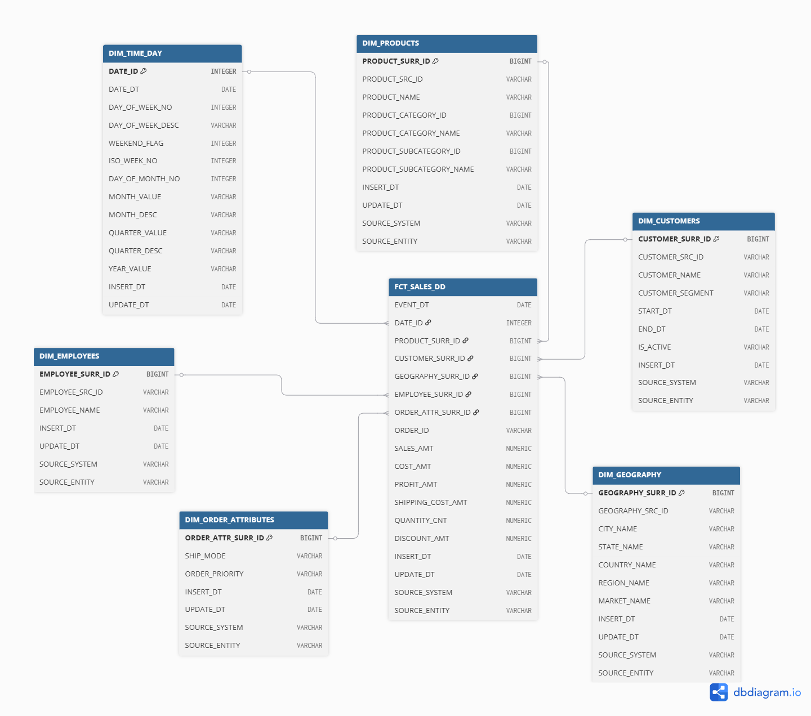
Figure 1. Star Schema

SNOWFLAKE SCHEMA MODEL
The snowflake schema applies normalization to the star schema by breaking down denormalized dimension tables into multiple related tables. This reduces redundancy but increases join complexity.
SNOWFLAKE NORMALIZATION PROCESS:
Step 1: Normalize Product Dimension
- Star: DIM_PRODUCTS (flat, with PRODUCT_CATEGORY_NAME and PRODUCT_SUBCATEGORY_NAME embedded)
- Snowflake: Break into 3 tables:
  - DIM_PRODUCTS (core product attributes)
    - PRODUCT_SURR_ID (PK)
    - PRODUCT_SRC_ID
    - PRODUCT_NAME
    - PRODUCT_SUBCATEGORY_ID (FK to DIM_PRODUCT_SUBCATEGORIES)
    - INSERT_DT, UPDATE_DT, SOURCE_SYSTEM, SOURCE_ENTITY
  - DIM_PRODUCT_SUBCATEGORIES (intermediate level)
    - PRODUCT_SUBCATEGORY_ID (PK)
    - PRODUCT_SUBCATEGORY_NAME
    - PRODUCT_CATEGORY_ID (FK to DIM_PRODUCT_CATEGORIES)
  - DIM_PRODUCT_CATEGORIES (top level)
    - PRODUCT_CATEGORY_ID (PK)
    - PRODUCT_CATEGORY_NAME

Step 2: Normalize Geography Dimension
- Star: DIM_GEOGRAPHY (flat, with MARKET_NAME, REGION_NAME, COUNTRY_NAME, STATE_NAME, CITY_NAME all in one row)
- Snowflake: Break into 5 tables:
  - DIM_CITIES (leaf level)
    - CITY_ID (PK)
    - CITY_NAME
    - STATE_ID (FK to DIM_STATES)
  - DIM_STATES (state level)
    - STATE_ID (PK)
    - STATE_NAME
    - COUNTRY_ID (FK to DIM_COUNTRIES)
  - DIM_COUNTRIES (country level)
    - COUNTRY_ID (PK)
    - COUNTRY_NAME
    - REGION_ID (FK to DIM_REGIONS)
  - DIM_REGIONS (region level)
    - REGION_ID (PK)
    - REGION_NAME
    - MARKET_ID (FK to DIM_MARKETS)
  - DIM_MARKETS (top level)
    - MARKET_ID (PK)
    - MARKET_NAME (US, Canada, APAC, EU, EMEA, LATAM, Africa)

Step 3: Keep Other Dimensions as-is
- DIM_TIME_DAY: Already in normal form (calendar table, no further breakdown needed)
- DIM_CUSTOMERS: Keep as single table (minimal attributes, SCD2 history tracking)
- DIM_EMPLOYEES: Keep as single table (minimal attributes)
- DIM_ORDER_ATTRIBUTES: Keep as single table (junk dimension, low cardinality)

Step 4: Update Fact Table Foreign Keys
- Fact table FCT_SALES_DD would now reference:
  - PRODUCT_SURR_ID -> DIM_PRODUCTS
  - CITY_ID -> DIM_CITIES (instead of GEOGRAPHY_SURR_ID)
  - Other FKs remain unchanged

SNOWFLAKE SCHEMA TRADE-OFFS:
- Advantages:
  - Reduced data redundancy
  - Easier to maintain dimension updates
  - Better for slowly changing dimension management per level
- Disadvantages:
  - More complex queries (more joins needed)
  - Slower query performance compared to star
  - Additional foreign key constraints to maintain

RECOMMENDATION FOR THIS PROJECT:
- Use STAR SCHEMA for the Data Warehouse
- Reason: Retail sales queries prioritize speed and simplicity
- Queries like "Which product categories generate highest profit?" require simple star joins
- Snowflake would be beneficial if dimension updates were frequent at different hierarchy levels
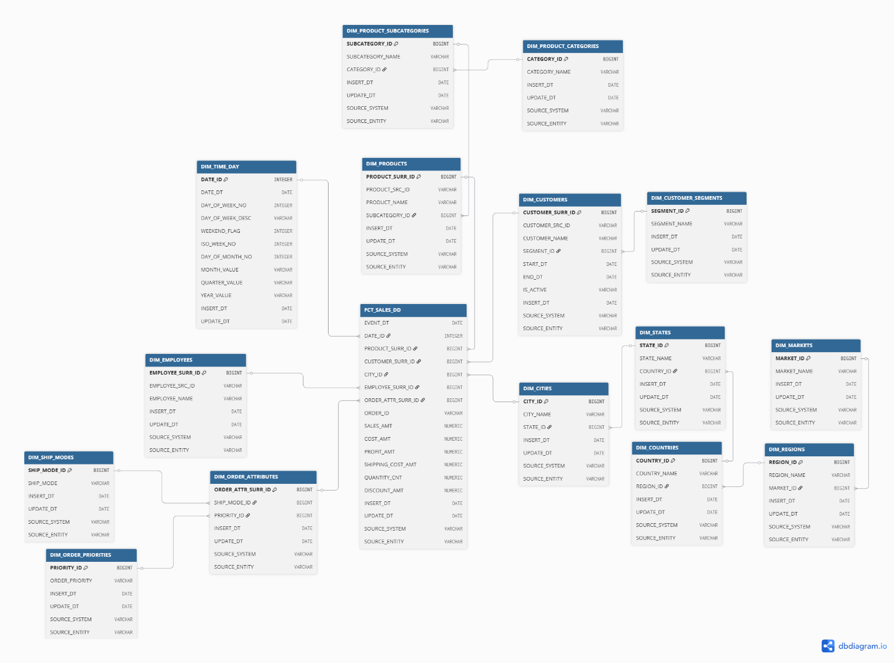
Figure 2. Snowflake Schema

Business Layer 3NF

Design Process
Slowly Changing Dimensions (SCD)
Slowly Changing Dimensions describe how dimension data changes over time and how those changes are handled in the Data Warehouse. There are three main types:
- SCD Type 0 — No changes allowed. The value is fixed at load time and never updated. Used for attributes that should never change (e.g. calendar dates, original transaction codes).
- SCD Type 1 — Overwrite. When a value changes, the old value is simply replaced with the new one. No history is kept. Used when historical accuracy of that attribute is not needed for reporting.
- SCD Type 2 — Add a new row. When a value changes, the existing row is closed (END_DT updated, IS_ACTIVE = N) and a new row is inserted with the new value (START_DT = change date, END_DT = 9999-12-31, IS_ACTIVE = Y). Full history is preserved. Used when it matters what value was in effect at the time of a transaction.
In this project CE_CUSTOMERS_SCD uses SCD Type 2 because a customer's segment (Consumer, Corporate, Home Office) can change, and it is analytically important to know which segment the customer belonged to at the time each order was placed.
STEP 1: Entity Identification
The BL_3NF schema serves as the integration and cleansing layer between the raw source staging area (SA_DOMESTIC, SA_INTERNATIONAL) and the dimensional model (BL_DM). Each business entity, regardless of how many source systems it appears in, is represented by exactly one CE_ table. There is no separate "domestic employee" table and "international employee" table; there is one CE_EMPLOYEES table loaded from both sources.
The following entities were identified across both source systems: Dates, Products (with Category and Sub-Category hierarchy), Customers, Geography (Market, Region, Country, State, City), Employees, Order Attributes (Ship Mode and Order Priority), and Sales transactions.
STEP 2: Hierarchical Decomposition
Hierarchies identified within the entities are broken down into separate CE_ tables at the 3NF layer:
- Product hierarchy: CE_PRODUCT_CATEGORIES -> CE_PRODUCT_SUBCATEGORIES -> CE_PRODUCTS
- Geography hierarchy: CE_MARKETS -> CE_REGIONS -> CE_COUNTRIES -> CE_STATES -> CE_CITIES
Each level references its parent via a foreign key, ensuring no redundancy at the 3NF layer.
STEP 3: Normalization to 3NF
Each CE_ table contains only attributes that directly describe that entity, no transitive dependencies. SCD types were assigned as follows:
- CE_CUSTOMERS_SCD -> SCD Type 2 (tracks historical changes to customer segment)
- All other CE_ tables -> SCD Type 1 (overwrite on change) or Type 0 (dates, junk attributes that never change)
Every CE_ table contains a mandatory default row with surrogate ID = -1 and all descriptive fields set to 'N/A'. This is used as the FK target when source data is missing a value (for example, Employee Name is not available in the International source system). Surrogate keys in all CE_ tables are generated by sequences, never SERIAL type.
STEP 4: Relationships
Relationships between CE_ tables are enforced via foreign keys. The composite primary key rule applies to CE_CUSTOMERS_SCD: its PK is (CUSTOMER_ID + START_DT). No FK database constraint is created between CE_SALES and CE_CUSTOMERS_SCD. All other FK constraints between CE_ tables are enforced normally.

3NF Model
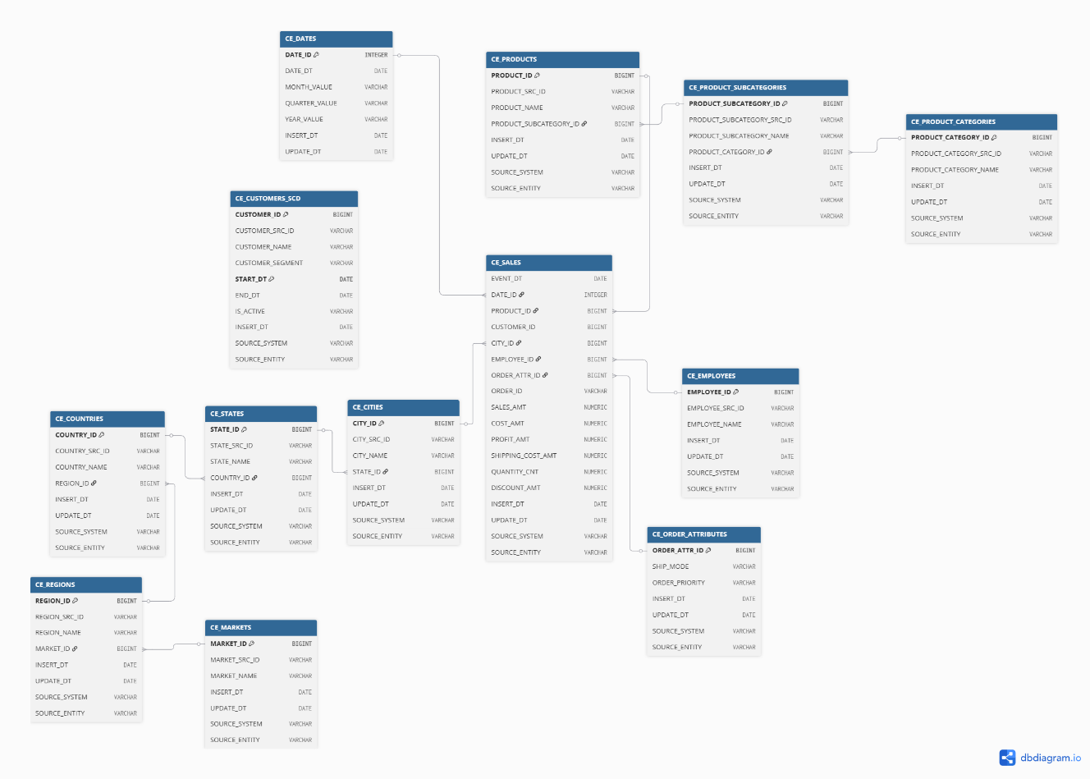
Figure 3. 3NF model

Table Definitions
CE_DATES (SCD Type 0, calendar dates never change)
Column Name | Description | Data Type
DATE_ID | Surrogate primary key; integer in YYYYMMDD format. | INTEGER NOT NULL
DATE_DT | The actual calendar date. | DATE NOT NULL
DAY_OF_WEEK_NO | Day number within the week (1 = Monday … 7 = Sunday). | INTEGER NOT NULL
DAY_OF_WEEK_DESC | Full name of the day. | VARCHAR(25) NOT NULL
WEEKEND_FLAG | 1 if the day is a weekend day (Saturday or Sunday), 0 otherwise. | INTEGER NOT NULL
ISO_WEEK_NO | ISO week number within the year. | INTEGER NOT NULL
DAY_OF_MONTH_NO | Day number within the month (1–31). | INTEGER NOT NULL
MONTH_VALUE | Two-digit month string (01–12). | VARCHAR(2) NOT NULL
MONTH_DESC | Full month name. | VARCHAR(25) NOT NULL
QUARTER_VALUE | Quarter number (1–4). | VARCHAR(1) NOT NULL
QUARTER_DESC | Quarter label (Q1, Q2, Q3, Q4). | VARCHAR(2) NOT NULL
YEAR_VALUE | Four-digit year string (e.g. 2024). | VARCHAR(4) NOT NULL
INSERT_DT | The date this row was inserted into the DWH. | DATE NOT NULL
UPDATE_DT | The date this row was last updated. | DATE NOT NULL
CE_PRODUCT_CATEGORIES (SCD Type 1)
Column Name | Description | Data Type
PRODUCT_CATEGORY_ID | Surrogate PK, generated by sequence | BIGINT NOT NULL
PRODUCT_CATEGORY_SRC_ID | Natural key from source | VARCHAR(50) NOT NULL
PRODUCT_CATEGORY_NAME | Category name (Furniture, Office Supplies, Technology) | VARCHAR(100) NOT NULL
INSERT_DT | Date row was inserted | DATE NOT NULL
UPDATE_DT | Date row was last updated | DATE NOT NULL
SOURCE_SYSTEM | e.g. SA_DOMESTIC or SA_INTERNATIONAL | VARCHAR(100) NOT NULL
SOURCE_ENTITY | e.g. SRC_DOMESTIC_SALES | VARCHAR(100) NOT NULL
CE_PRODUCT_SUBCATEGORIES (SCD Type 1)
Column Name | Description | Data Type
PRODUCT_SUBCATEGORY_ID | Surrogate PK, generated by sequence | BIGINT NOT NULL
PRODUCT_SUBCATEGORY_SRC_ID | Natural key from source | VARCHAR(50) NOT NULL
PRODUCT_SUBCATEGORY_NAME | Sub-category name (e.g. Paper, Phones, Chairs) | VARCHAR(100) NOT NULL
PRODUCT_CATEGORY_ID | FK to CE_PRODUCT_CATEGORIES | BIGINT NOT NULL
INSERT_DT | Date row was inserted | DATE NOT NULL
UPDATE_DT | Date row was last updated | DATE NOT NULL
SOURCE_SYSTEM | Source system identifier | VARCHAR(100) NOT NULL
SOURCE_ENTITY | Source table identifier | VARCHAR(100) NOT NULL
CE_PRODUCTS (SCD Type 1, conformed dimension, loaded from both source systems)
Column Name | Description | Data Type
PRODUCT_ID | Surrogate PK, generated by sequence | BIGINT NOT NULL
PRODUCT_SRC_ID | Natural key from source (e.g. OFF-PA-10002005) | VARCHAR(50) NOT NULL
PRODUCT_NAME | Full product name | VARCHAR(255) NOT NULL
PRODUCT_SUBCATEGORY_ID | FK to CE_PRODUCT_SUBCATEGORIES | BIGINT NOT NULL
INSERT_DT | Date row was inserted | DATE NOT NULL
UPDATE_DT | Date row was last updated | DATE NOT NULL
SOURCE_SYSTEM | Source system identifier | VARCHAR(100) NOT NULL
SOURCE_ENTITY | Source table identifier | VARCHAR(100) NOT NULL
CE_CUSTOMERS_SCD (SCD Type 2, tracks historical changes to customer segment)
Column Name | Description | Data Type
CUSTOMER_ID | Surrogate PK component, generated by sequence | BIGINT NOT NULL
CUSTOMER_SRC_ID | Natural key from source (e.g. DOM-LS-172304) | VARCHAR(50) NOT NULL
CUSTOMER_NAME | Full name of the customer | VARCHAR(255) NOT NULL
CUSTOMER_SEGMENT | Consumer, Corporate, or Home Office | VARCHAR(50) NOT NULL
START_DT | SCD2 effective start date. Default: 1990-01-01 | DATE NOT NULL
END_DT | SCD2 effective end date. Default: 9999-12-31 | DATE NOT NULL
IS_ACTIVE | Y = current active version, N = historical | VARCHAR(1) NOT NULL
INSERT_DT | Date row was inserted | DATE NOT NULL
SOURCE_SYSTEM | Source system identifier | VARCHAR(100) NOT NULL
SOURCE_ENTITY | Source table identifier | VARCHAR(100) NOT NULL
Note: PK is composite (CUSTOMER_ID + START_DT) for SCD Type 2 on 3NF layer. No FK database constraint is created from CE_SALES to this table.
CE_MARKETS (SCD Type 1)
Column Name | Description | Data Type
MARKET_ID | Surrogate PK, generated by sequence | BIGINT NOT NULL
MARKET_SRC_ID | Natural key from source | VARCHAR(50) NOT NULL
MARKET_NAME | e.g. US, Canada, APAC, EU, EMEA, LATAM, Africa | VARCHAR(50) NOT NULL
INSERT_DT | Date row was inserted | DATE NOT NULL
UPDATE_DT | Date row was last updated | DATE NOT NULL
SOURCE_SYSTEM | Source system identifier | VARCHAR(100) NOT NULL
SOURCE_ENTITY | Source table identifier | VARCHAR(100) NOT NULL
CE_REGIONS (SCD Type 1)
Column Name | Description | Data Type
REGION_ID | Surrogate PK, generated by sequence | BIGINT NOT NULL
REGION_SRC_ID | Natural key from source | VARCHAR(50) NOT NULL
REGION_NAME | e.g. West, Central, North Asia | VARCHAR(100) NOT NULL
MARKET_ID | FK to CE_MARKETS | BIGINT NOT NULL
INSERT_DT | Date row was inserted | DATE NOT NULL
UPDATE_DT | Date row was last updated | DATE NOT NULL
SOURCE_SYSTEM | Source system identifier | VARCHAR(100) NOT NULL
SOURCE_ENTITY | Source table identifier | VARCHAR(100) NOT NULL
CE_COUNTRIES (SCD Type 1)
Column Name | Description | Data Type
COUNTRY_ID | Surrogate PK, generated by sequence | BIGINT NOT NULL
COUNTRY_SRC_ID | Natural key from source | VARCHAR(50) NOT NULL
COUNTRY_NAME | e.g. United States, France, Japan | VARCHAR(100) NOT NULL
REGION_ID | FK to CE_REGIONS | BIGINT NOT NULL
INSERT_DT | Date row was inserted | DATE NOT NULL
UPDATE_DT | Date row was last updated | DATE NOT NULL
SOURCE_SYSTEM | Source system identifier | VARCHAR(100) NOT NULL
SOURCE_ENTITY | Source table identifier | VARCHAR(100) NOT NULL
CE_STATES (SCD Type 1)
Column Name | Description | Data Type
STATE_ID | Surrogate PK, generated by sequence | BIGINT NOT NULL
STATE_SRC_ID | Natural key from source | VARCHAR(50) NOT NULL
STATE_NAME | State or province. 'N/A' for Domestic records where State is not tracked | VARCHAR(100) NOT NULL
COUNTRY_ID | FK to CE_COUNTRIES | BIGINT NOT NULL
INSERT_DT | Date row was inserted | DATE NOT NULL
UPDATE_DT | Date row was last updated | DATE NOT NULL
SOURCE_SYSTEM | Source system identifier | VARCHAR(100) NOT NULL
SOURCE_ENTITY | Source table identifier | VARCHAR(100) NOT NULL
CE_CITIES (SCD Type 1)
Column Name | Description | Data Type
CITY_ID | Surrogate PK, generated by sequence | BIGINT NOT NULL
CITY_SRC_ID | Natural key: concatenated City + Country + Region (no single source key exists) | VARCHAR(255) NOT NULL
CITY_NAME | City name where the order was placed | VARCHAR(100) NOT NULL
STATE_ID | FK to CE_STATES | BIGINT NOT NULL
INSERT_DT | Date row was inserted | DATE NOT NULL
UPDATE_DT | Date row was last updated | DATE NOT NULL
SOURCE_SYSTEM | Source system identifier | VARCHAR(100) NOT NULL
SOURCE_ENTITY | Source table identifier | VARCHAR(100) NOT NULL
CE_EMPLOYEES (SCD Type 1, single table populated from both source systems)
Column Name | Description | Data Type
EMPLOYEE_ID | Surrogate PK, generated by sequence | BIGINT NOT NULL
EMPLOYEE_SRC_ID | Natural key from source (e.g. EMP-1001) | VARCHAR(50) NOT NULL
EMPLOYEE_NAME | Full name. 'N/A' if employee only appears in International system | VARCHAR(255) NOT NULL
INSERT_DT | Date row was inserted | DATE NOT NULL
UPDATE_DT | Date row was last updated | DATE NOT NULL
SOURCE_SYSTEM | Source system identifier | VARCHAR(100) NOT NULL
SOURCE_ENTITY | Source table identifier | VARCHAR(100) NOT NULL
CE_ORDER_ATTRIBUTES (SCD Type 0, junk dimension, combinations never change)
Column Name | Description | Data Type
ORDER_ATTR_ID | Surrogate PK, generated by sequence | BIGINT NOT NULL
SHIP_MODE | First Class, Second Class, Standard Class, Same Day, or N/A | VARCHAR(50) NOT NULL
ORDER_PRIORITY | Critical, High, Medium, Low, or N/A | VARCHAR(25) NOT NULL
INSERT_DT | Date row was inserted | DATE NOT NULL
UPDATE_DT | Date row was last updated | DATE NOT NULL
SOURCE_SYSTEM | SA_DOMESTIC for real rows; MANUAL for N/A default row | VARCHAR(100) NOT NULL
SOURCE_ENTITY | Source table identifier | VARCHAR(100) NOT NULL
CE_SALES (Fact table at 3NF level)
Column Name | Description | Data Type
EVENT_DT | Order date of the transaction — mandatory time key | DATE NOT NULL
DATE_ID | FK to CE_DATES | INTEGER NOT NULL
PRODUCT_ID | FK to CE_PRODUCTS | BIGINT NOT NULL
CUSTOMER_ID | Logical FK to CE_CUSTOMERS_SCD (no DB constraint) | BIGINT NOT NULL
CITY_ID | FK to CE_CITIES | BIGINT NOT NULL
EMPLOYEE_ID | FK to CE_EMPLOYEES | BIGINT NOT NULL
ORDER_ATTR_ID | FK to CE_ORDER_ATTRIBUTES | BIGINT NOT NULL
ORDER_ID | Degenerate dimension — original order number from source | VARCHAR(50) NOT NULL
SALES_AMT | Revenue for the order line in USD | NUMERIC(15,2)
COST_AMT | Cost of goods sold (Sales minus Profit) | NUMERIC(15,2)
PROFIT_AMT | Profit earned on the order line | NUMERIC(15,2)
SHIPPING_COST_AMT | Cost to ship the order line | NUMERIC(15,2)
QUANTITY_CNT | Number of units sold | NUMERIC(10,0)
DISCOUNT_AMT | Discount as a proportion (e.g. 0.15 = 15%) | NUMERIC(5,4)
INSERT_DT | Date row was inserted | DATE NOT NULL
UPDATE_DT | Date row was last updated | DATE NOT NULL
SOURCE_SYSTEM | SA_DOMESTIC or SA_INTERNATIONAL | VARCHAR(100) NOT NULL
SOURCE_ENTITY | SRC_DOMESTIC_SALES or SRC_INTERNATIONAL_SALES | VARCHAR(100) NOT NULL

Business Layer Dimensional Model

Design Process
The BL_DM schema is the dimensional layer built on top of BL_3NF. Dimensions are populated by denormalizing the normalized CE_ tables, hierarchies that exist as separate tables in 3NF are flattened into single wide dimension tables. The fact table FCT_SALES_DD references all dimensions via surrogate keys.
Key design decisions:
- All surrogate keys are generated by sequences, never SERIAL type
- DIM_TIME_DAY is populated independently from a SQL script, not from the 3NF layer
- DIM_CUSTOMERS uses SCD Type 2 — it is the only dimension with START_DT, END_DT, IS_ACTIVE columns
- All other dimensions use SCD Type 1 (overwrite) or Type 0 (never change)
- All non-KPI columns are NOT NULL; KPI/metric columns are nullable
- International records reference the default -1 row in DIM_ORDER_ATTRIBUTES since Ship Mode and Order Priority are not tracked in that source system

Dimensional Model (star schema)
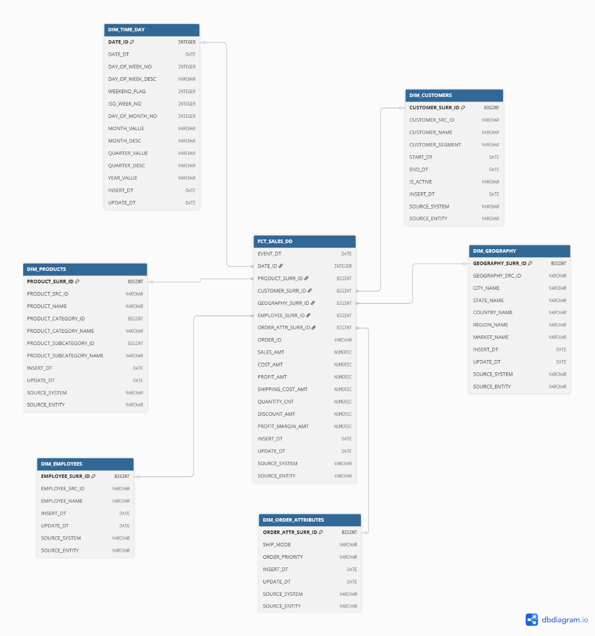
Figure 4. star_schema_dm.png

Metrics Description
The following metrics are stored in FCT_SALES_DD:
Metric | Type | Description | Additivity
SALES_AMT | Base metric | Total revenue for the order line in USD | Fully additive across all dimensions
COST_AMT | Base metric | Cost of goods sold — derived as Sales minus Profit | Fully additive across all dimensions
PROFIT_AMT | Base metric | Profit earned on the order line — derived as Sales minus Cost | Fully additive across all dimensions
SHIPPING_COST_  AMT | Base metric | Cost incurred to ship the order line | Fully additive across all dimensions
QUANTITY_CNT | Base metric | Number of units sold on the order line | Fully additive across all dimensions
DISCOUNT_AMT | Base metric | Discount applied, stored as proportion (e.g. 0.15 = 15%) | Non-additive as percentage; stored alongside SALES_AMT for context
PROFIT_MARGIN  _AMT | Calculated metric | PROFIT_AMT / SALES_AMT — profit margin ratio per order line | Non-additive; must be recalculated after aggregation
Calculated metric explanation:
PROFIT_MARGIN_AMT = PROFIT_AMT / SALES_AMT
This metric expresses how much profit is earned per dollar of revenue on each order line. For example, a row with SALES_AMT = 18.55 and PROFIT_AMT = 9.11 gives PROFIT_MARGIN_AMT = 0.491, meaning 49.1% profit margin. This metric is stored at the row level for reference but must be recalculated (SUM(PROFIT_AMT) / SUM(SALES_AMT)) when aggregating across multiple rows, because ratios are not directly additive.
Additional calculated metric added to FCT_SALES_DD:
Column Name | Description | Data Type
PROFIT_MARGIN_AMT | Calculated: PROFIT_AMT / SALES_AMT. Profit margin ratio per order line. Non-additive; must be recalculated as SUM(PROFIT_AMT)/SUM(SALES_AMT) when aggregating. | NUMERIC(10,4)

Dimension Table Summary
Table | SCD Type | Populated From | Notes
DIM_TIME_DAY | Type 0 | SQL script only | Never changes; populated once for full 2024-2025 range
DIM_PRODUCTS | Type 1 | CE_PRODUCTS + CE_PRODUCT_CATEGORIES + CE_PRODUCT_SUBCATEGORIES | Hierarchy flattened into one table
DIM_CUSTOMERS | Type 2 | CE_CUSTOMERS_SCD | Tracks segment changes; has START_DT, END_DT, IS_ACTIVE
DIM_GEOGRAPHY | Type 1 | CE_CITIES + CE_STATES + CE_COUNTRIES + CE_REGIONS + CE_MARKETS | Full geography hierarchy flattened into one table
DIM_EMPLOYEES | Type 1 | CE_EMPLOYEES | Employee Name = N/A for International-only employees
DIM_ORDER_  ATTRIBUTES | Type 0 | CE_ORDER_ATTRIBUTES | International records use default -1 row

Logical Scheme

Data Flow

Fact Table Partitioning Strategy

